# Author

Ali Amir – 14874

## Stakeholder

Rafay Shoaib – 14942

# Authors’ Note

This is a very detailed dashboard it has a lot of functionality, detailing, interactivity, charts and multiple dashboards. It uses R scripts so you may need to install before you can open the dashboard. To install R you need to follow a detailed process:

## How to Download and Install R:

By default, Power BI Desktop does not include, deploy, or install the R engine. To run R scripts in Power BI Desktop, you must separately install R on your local computer. You can download and install R for free from many locations, including the [Revolution Open download page](https://mran.revolutionanalytics.com/download), and the [CRAN Repository](https://cran.r-project.org/bin/windows/base/). The current release of R scripting in Power BI Desktop supports Unicode characters as well as spaces (empty characters) in the installation path.

After you've installed R, Power BI Desktop enables it automatically. To verify that Power BI Desktop has enabled R in the correct location, follow these steps:

* From the Power BI Desktop menu, select File > Options and settings > Options.
* On the left side of the Options page, under Global, select R scripting.
* Under R script options, verify that your local R installation is specified in Detected R home directories and that it properly reflects the local R installation you want Power BI Desktop to use. In the following image, the path to the local installation of R is C:\Program Files\R Open\R-3.5.3\

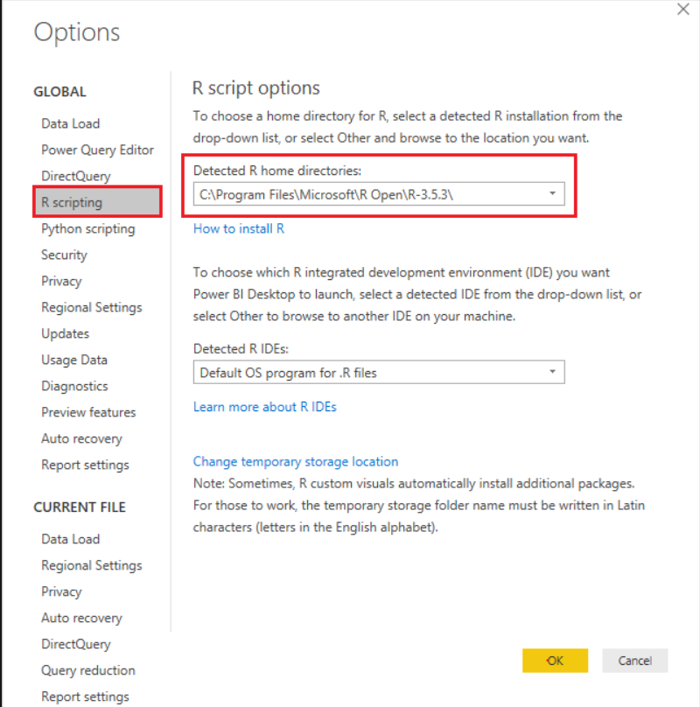

Then you can reopen my downloaded dashboard.

Disclaimer: If you don’t Enable R Scripts, you will not be able to see the Forecasting that I have successfully achieved on Power BI.

Furthermore, many visuals that you see, some labeled as, Advanced Pie Chart, Parallel Coordinates, Forecasting, Radar Maps, for these I have used advanced Visuals, they are usually uncommon on the basic level.

The last thing I want to mention is that you don’t like us to upload google folder and I can understand why, and I upload the pdf and the submit the documents the way you want to. However, I will also upload a google folder in which I will provide a recorded video where you can see how the detailed working of the dashboard.

Link to the google folder: <https://drive.google.com/drive/folders/11Y50cwuVRiEPTRsBdm5mg9lcV7c3Ek_r?usp=sharing>

You may skip: Business Knowledge article in this document.

# 1. Business Knowledge

Simply put, E Commerce is ‘Using Electronic Platform for Business Transactions’. It is also called a ‘Virtual Market Place’. Every minute millions of people from all over the world are logging into the Internet looking for some information, for product, services, to look for news, download music, for online shopping and so on. Every individual is looking for something that he would like to obtain or buy online instead of having to go through a physical transaction. Imagine what this means to the business organizations. If they are able to identify and access those individual users who have a specific need or want, they have a ready customer in waiting.

One could wonder whether it is the online community or the technology that is paving way for E Commerce. The answer is that both these factors are driving the E Commerce. The technological developments are providing the backbone for business transactions to take place and the growing volumes of users buying online is making it possible for E Commerce and markets to grow.

E Commerce is characterized by Business to Business and Business to Customer business models. We are very familiar with the Business to Customer model for banking; insurance as well as online shopping, online booking etc. that have become very popular and accepted modes in our daily lives. On the B to B front too, business organizations have re-engineered their Business processes including Advertising, Marketing, Sales Order Management besides Supply chain management and Customer Relationship management to suit the E Commerce mode. Dell has successfully adapted ‘online selling’ model on a global scale. It allows the customers to ‘configure the model’ and to ‘Order Online’. Once the transaction has been successfully carried out and payment has been received, Dell executes the order and ensures that the DELL Products are delivered at the Customer’s doorstep within seven working days. DELL has not only used E Commerce successfully as its major selling channel, but at the backend they have put in place ‘Built to Order’ process where in the Computer is assembled against the specific customer order and is delivered to the customer. By integrating E Commerce and its Manufacturing process, DELL has managed to do away with holding inventories and managed to bring its costs down.

E Commerce has become a major business process for Global organizations and Multi-National Companies. Most MNCs depend upon ‘Online selling ‘as well as ‘Online Procurement’ on global scale. E Commerce has made it possible for them to access global markets as well as source raw materials from across the world. Besides, E Commerce has brought down the cost of selling as well as cost of procurement drastically adding to the bottom line. In the consumer world, Insurance, banking, airlines, and hospitality sectors have stood to benefit from E Commerce model of selling.

E Commerce is a reality. Several multiple technologies, platforms, agencies, and networks make it possible for E Commerce to happen. EDI and Online banking and transactions have been the major enablers that have made it possible for business transactions to take place.

It is simply amazing to think that with the click of a button one can buy, sell or affect financial transactions worth millions of dollars in a few minutes. However, this is true and E Commerce is the future.

## First thoughts on Dataset

At the first glance at the dataset I realized that there are no tables which represent web analysis data in any form. It means that my domain will solely be towards, sales, products, charts, growth etc.

This also means that the dashboard that I will be creating needs to be an analytical dashboard as it contains half a million rows which can also show forecasting and clustering. So, I need to use Tableau as my Business Intelligence tool. But my teammate also required to work on Tableau and I chose to work on Power BI as an only option (Qlik license caused issues after acquiring hence was left with Power BI).

# 2. Problems

I found the very basic and obvious problem in the dataset while wrangling that there are so many orders cancelled for some reason.

I decided that I will make such a detailed dashboard (like a product to the company itself) that anyone who uses it can identify the problems, solutions and can also see analytics and even Forecasting.

I know all this is going to be really hard to do Power BI but I will try my best.

# 3. Wrangling

I have gradually started to put emphasis on the wrangling phase of a project, I have finally put some considerable amount of effort in the wrangling phase to understand the data in a greater depth.

The file is attached which has quite a lot of wrangling done by you already, but some wrangling is accomplished by Rafay with good insights.

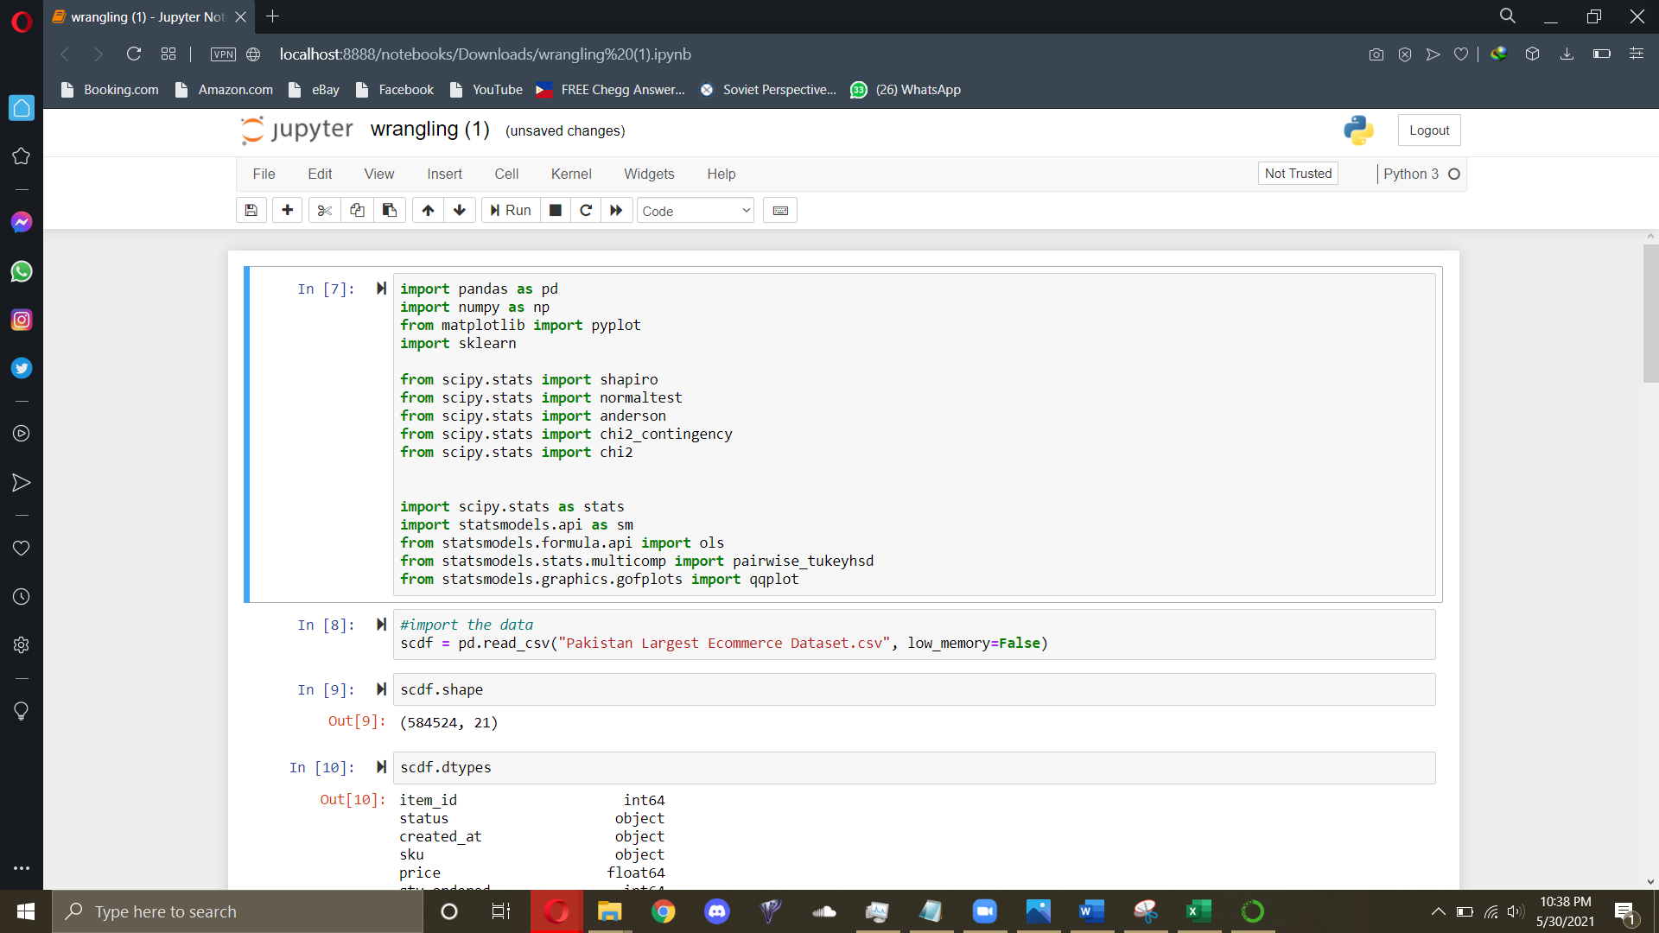

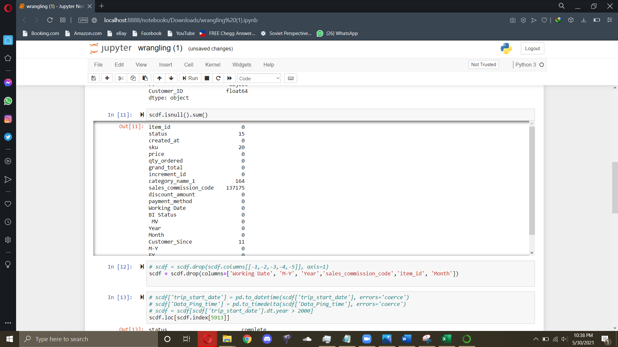 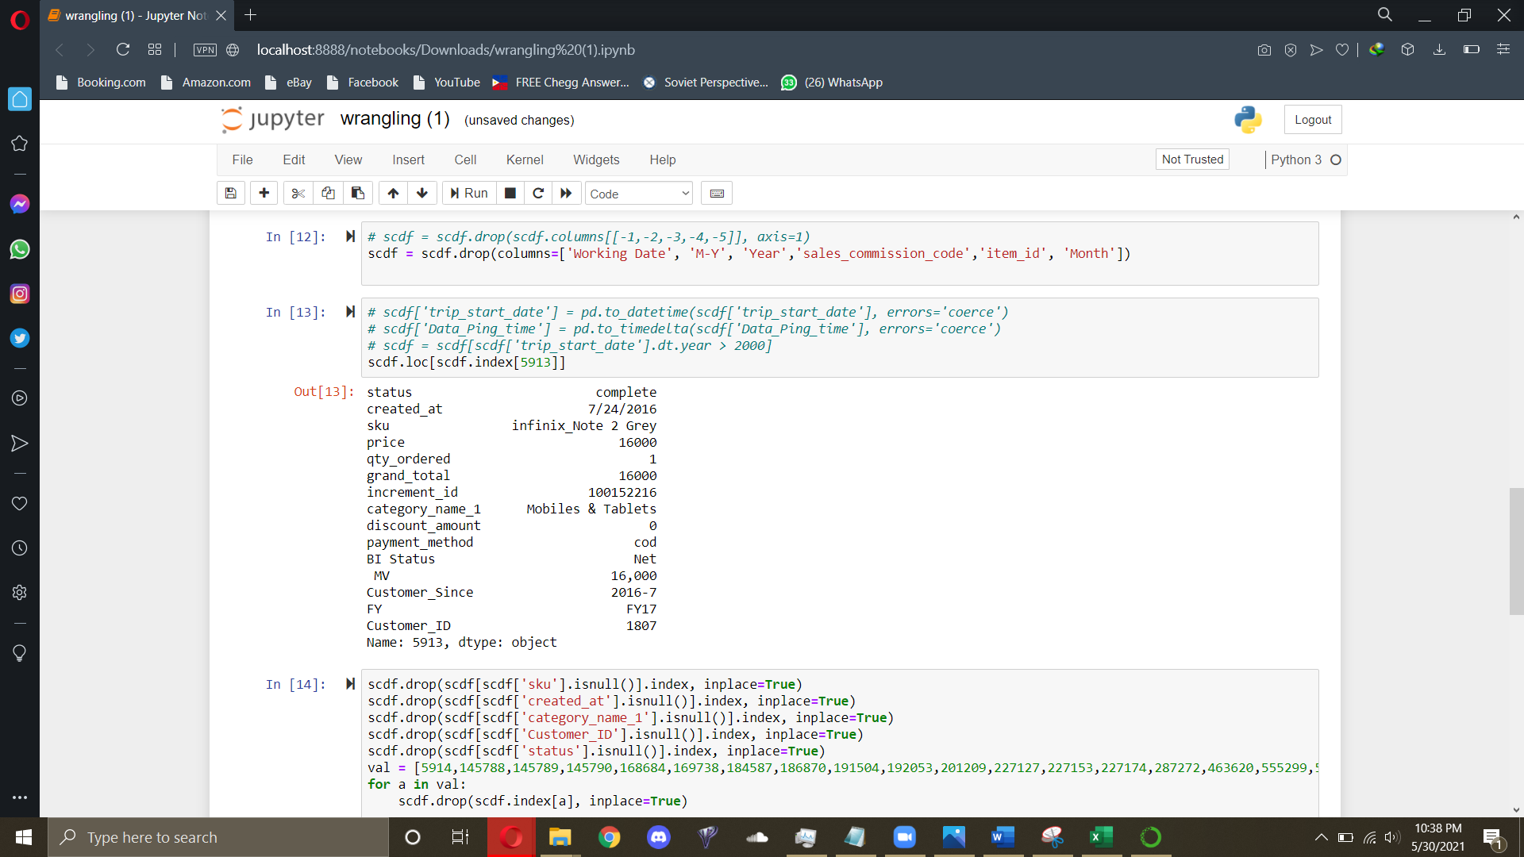

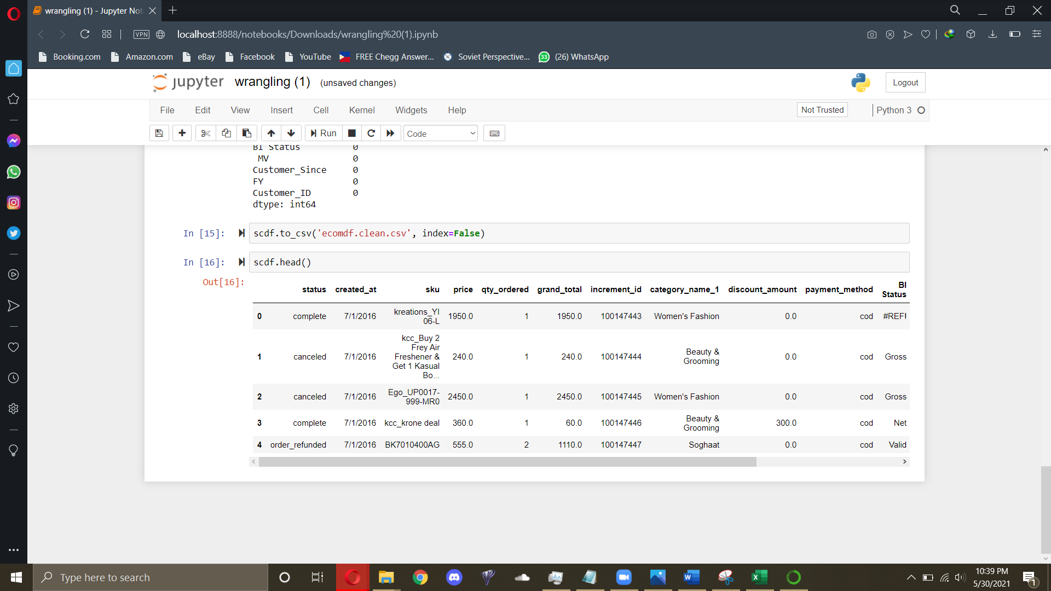

I have removed the missing values and have dropped the unnecessary values.

I have also removed a some errors from the Power BI Querry Editor

# 4. Solution Ideology

The solution Ideology is to know create specific charts which show a lot of detail at once and the eye can catch the picture in one glance and the user can maneuver around the dashboard to explore more details and find something even he didn’t come to find anything.

## 4.1 KPIs

Some major KPIs that I found in this dataset are:

1. Grand Total
2. Number of Products Sold
3. Accumulated Market Value
4. Total Discounts
5. Number of Customers

# 5. Dashboard Blueprint

The dashboard I am planning in my head needs to tactical, analytical and operational as well so I need identify which parts of the dashboards will work in what ways.

First, I found some chart ideas over the net, I attached all of those in one big, you can zoom in, the file name is Ecommerce-Dashboard-Charts-Internet.

Refer to the file: Ecommerce-Dashboard-Charts-Internet

# 6. Working of Dashboard

Opening the Dashboard gives you this page which you can get the general KPIs, a forecasted chart

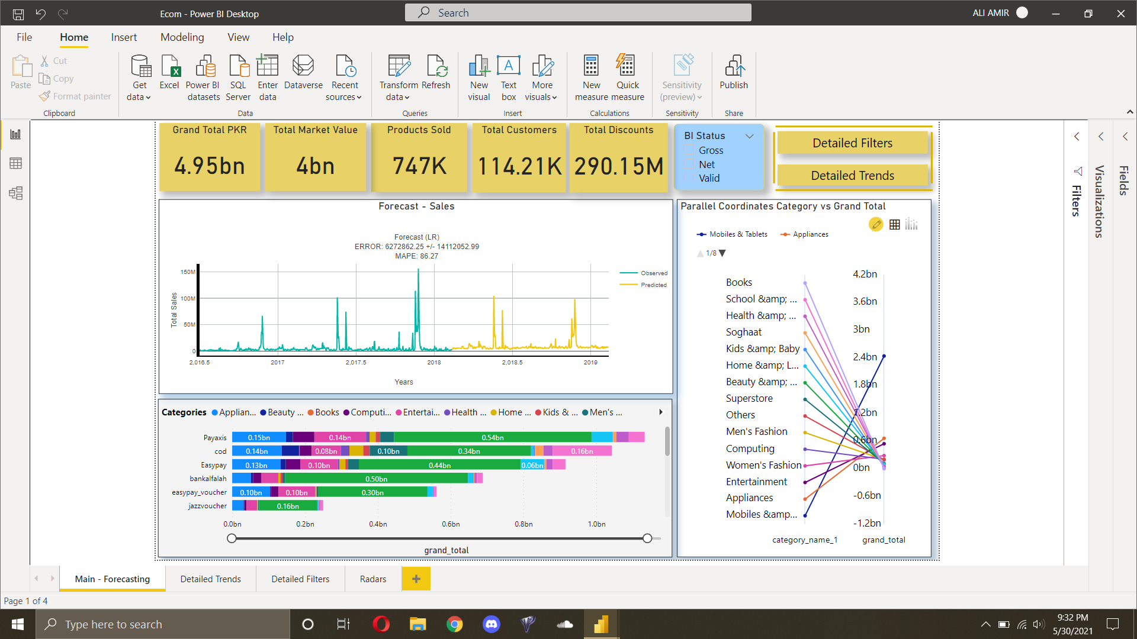

The front page of the of dashboard shows the basic KPIs, it shows forecasting, stacked bar chart, parallel and basic BI status filters.

Here you can see an expected growth and a good pictorial representation of grand_total of categorical products.

There are two buttons on the top right from where you can navigate through Detaiked Filters:

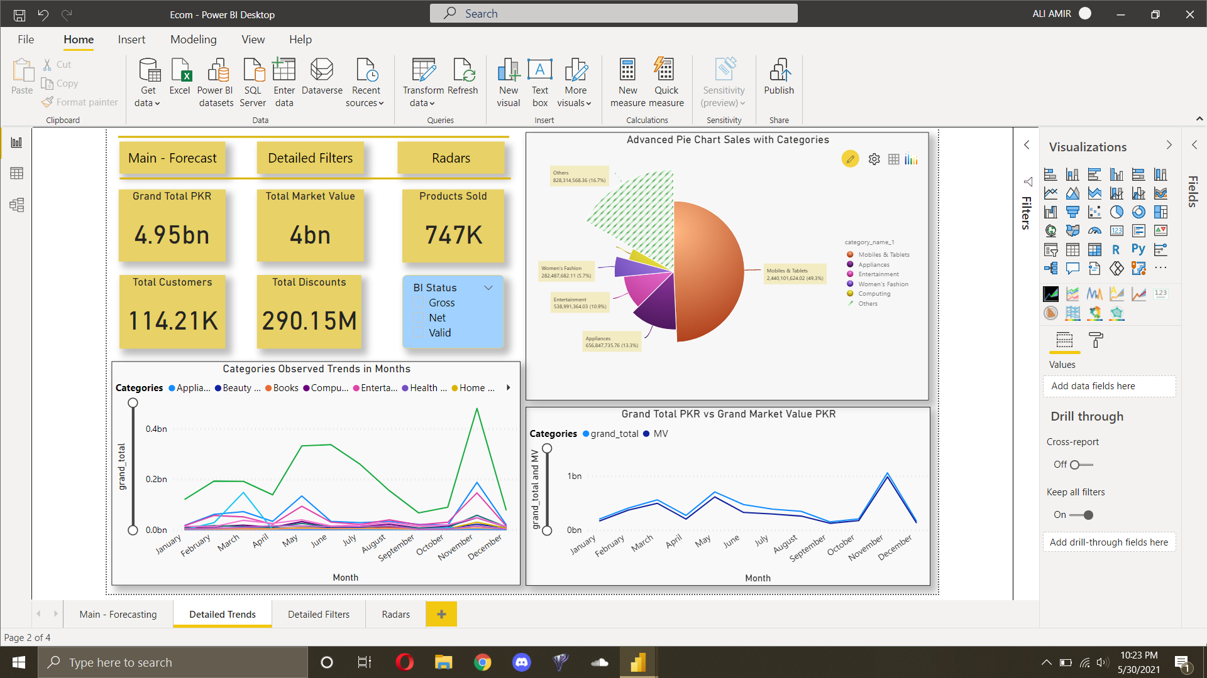

Here you can see the line charts of basic comparisons between categories and market value and grand_total in comparison to the yearly months.

On the top right there’s a detailed pie chart which shows the portions’ size as the grandtotal in comparison. On clicking any part of the pie, it will show details of that categories.

There are three buttons on the top left, one to go back to the main menu. Then there are radars and detailed filters

In Radars, you can see:

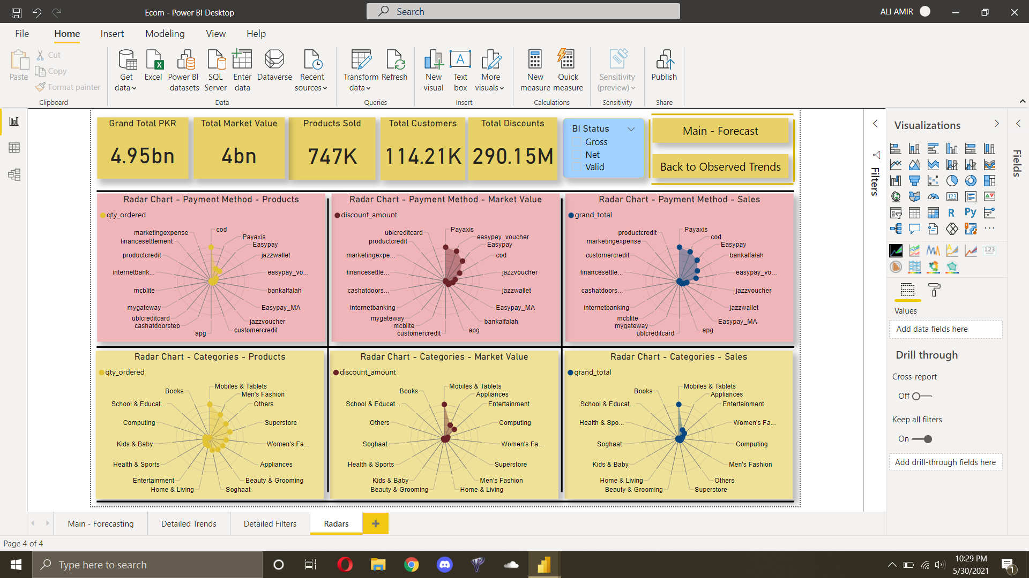

In the radar maps, you can not see the numeric values but you can compare the Payment methods and categories with respect to, Number of Products, Market value and Sales to see where the map is dense towards.

Here you can go back to the main page or back to the observerd Trends.

From any of the back pages you can go to Detailed Filters:

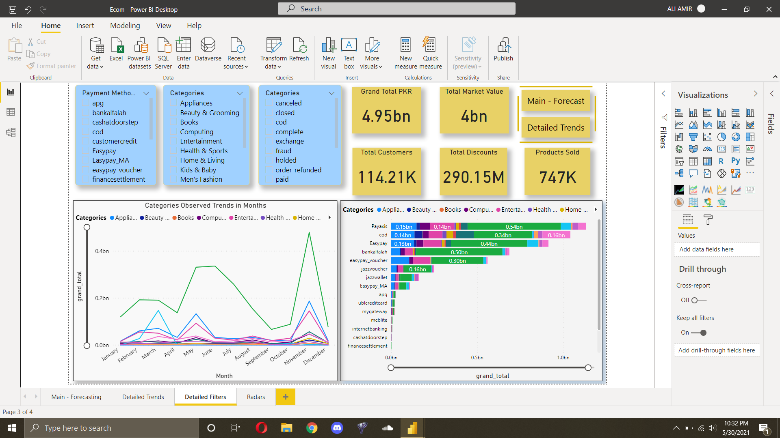

Here there are the filters available which gives this dashboard an operational perspective where you can identify things such why are orders getting cancelled.

# 7 References

* <https://www.managementstudyguide.com/understanding-e-commerce.htm>

# 8. Stakeholder’s Note

Rafay

* Helped in adding buttons to your dashboard to navigate through
* R scripts will be a little hard to do on Power BI, better to not do forecasting
* Add advanced visuals to increase interactivity.
* Dashboard gives a holistic breakup of product categories by all important metrics such as Sales, orders, payment methods, etc.
* Dashboard is very interactive where it can model the data as per the selected category in graphics.
* Radar chart shows the dispersion of data about payment methods and other categories. It helps in visualizing the dispersion of data with wide choices.
* I helped him in doing wrangling and removing because he does most of his data set edits through Power BI’s Querry Editor.
* Furthermore, I helped him in solving some of the complications that were coming in the advanced visuals.

I think this dashboard shows Ali’s excellent skills because the way he merged three types of dashboard of in one and made it look like a product.